**软件测试上机报告**



第四次上机作业

**学 院__智能与计算学部__**

**专 业__软件工程 __**

**姓 名__马天宇__________**

**学 号__3017218064______**

**年 级__2017级_________**

**班 级__软工一班__ _____**

# 一、实验要求

Tasks:

1. Install MuJava. The instruction of how to install and use Mujava can be seen in https://cs.gmu.edu/~offutt/mujava/ .

2. Two small programs are given for your task. BubbleSort.java is an implementation of bubble sort algorithm and BackPack.java is a solution of 01 backpack problem. Try to generate Mutants of 2 given programs with MuJava.

3. Write testing sets for 2 programs with Junit, and run mutants on the test sets with MuJava.f an error occurs, simply describe the error and analyze the cause of the error

# 二、源代码

TestBubbleSort.java:

import static org.junit.Assert.*;

import org.junit.Test;

import org.junit.After;

import org.junit.Before;

public class TestBubbleSort {

@Test

public void test() {

assertArrayEquals(BubbleSort.BubbleSort(new int[] {2,3,5,2,1,3,0}), new int[] {0,1,2,2,3,3,5});

}

}

TestBackPack.java:

import static org.junit.Assert.*;

import org.junit.Test;

import org.junit.After;

import org.junit.Before;

public class TestBackPack {

@Test

public void test() {

assertArrayEquals(new int[][] {{0, 0}, {0, 10}}, BackPack.BackPack_Solution(1,1,new int[] {1}, new int[] {10}));

}

}

# 三、运行结果

1. Set environment for the muJava system:

1.1 Set CLASSPATH. The Java CLASSPATH must include two µJava jar files and one standard Java jar file.

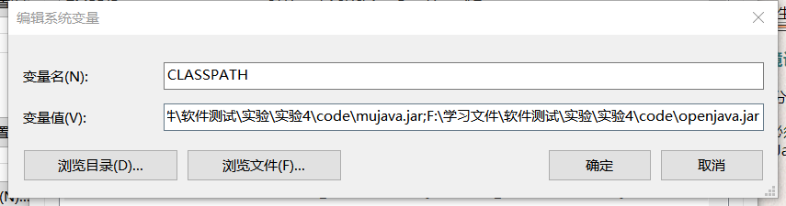

1.2 Modify the mujava.config file to point to a directory that contains the source Java files and muJava temporary files .

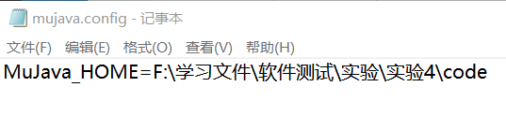

1.3 Create a directory structure for the muJava system in the $MuJava_HOME directory by using the muJava class "mujava.makeMuJavaStructure".

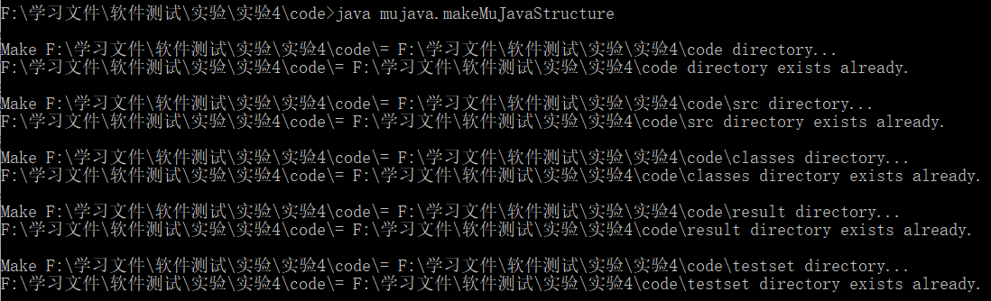

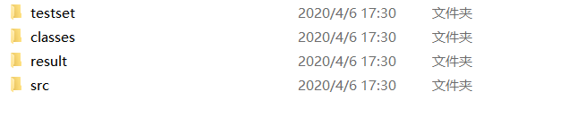

2.Generating Mutants with muJava

2.1 Put the source files to test to MuJava_HOME\src directory.

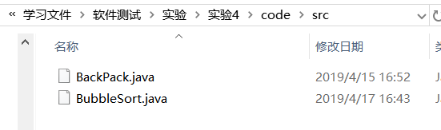

2.2 Compile all the Java files in MuJava_HOME\src and copy the .class files into the MuJava_HOME\classes\ directory.

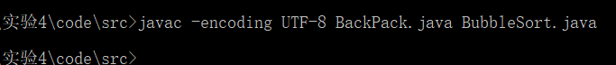

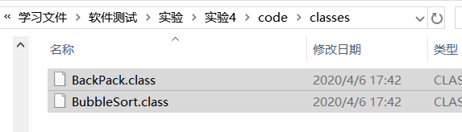

2.3 Start the GUI from the command line. Use it to generate mutants:

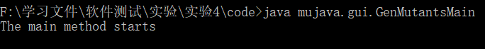

This command brings up a screen:

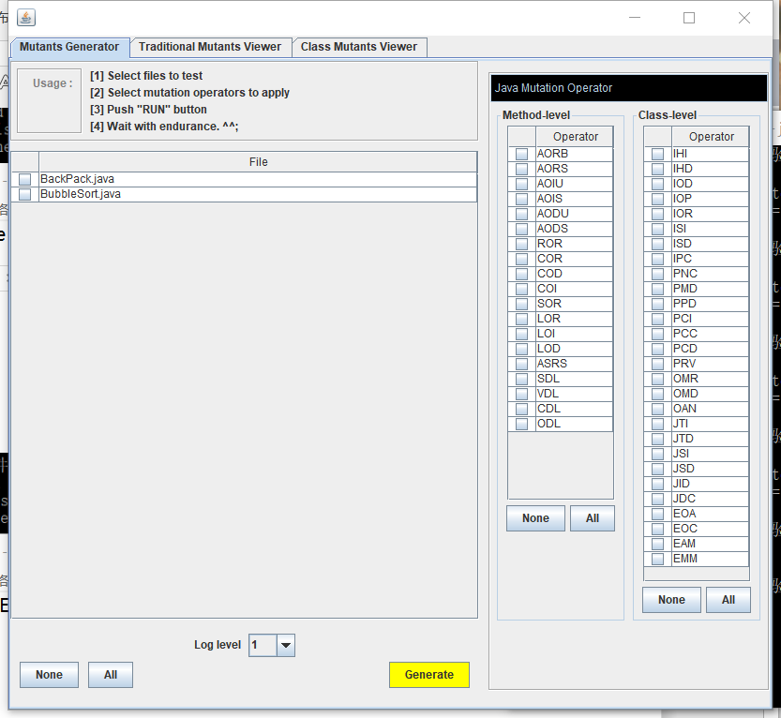

2.4 Select BackPack.java to mutate and select all mutation operators, then push RUN:

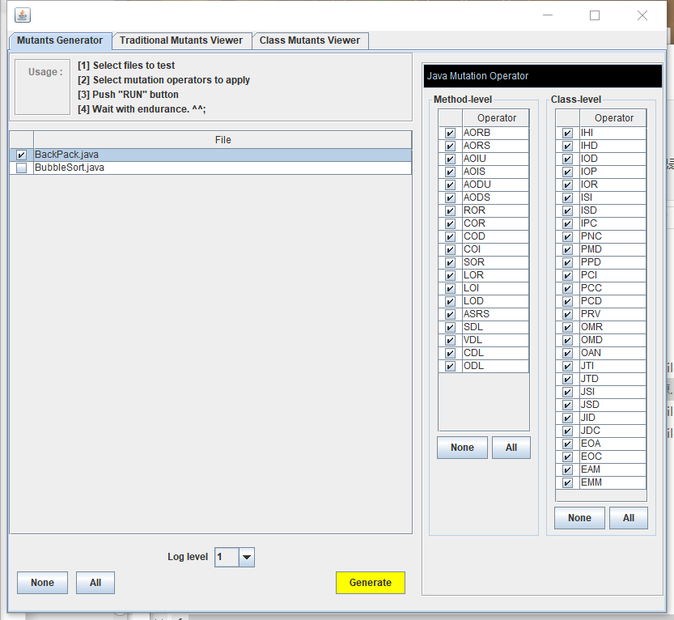

Mutants are generated:

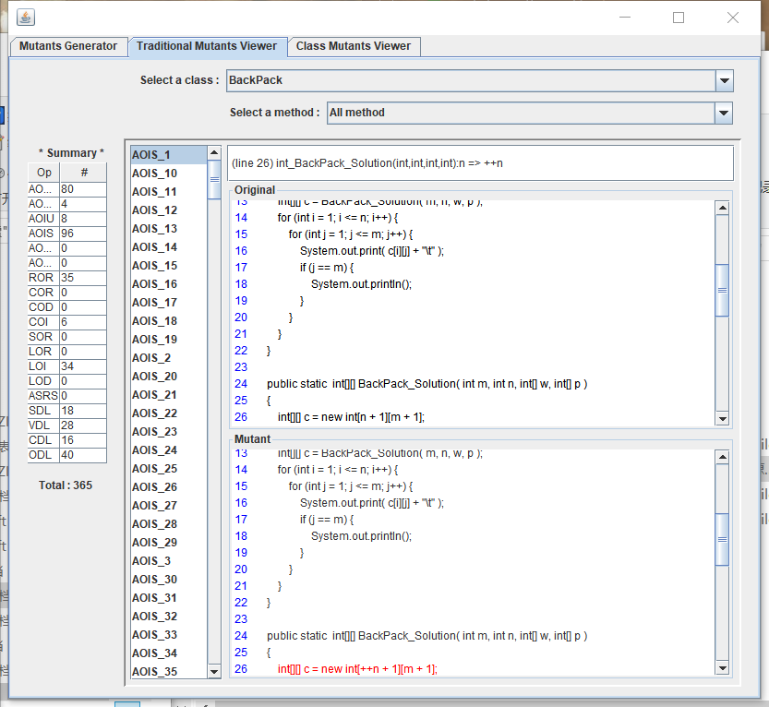

2.5 Select BubbleSort.java to mutate and select all mutation operators, then push RUN:

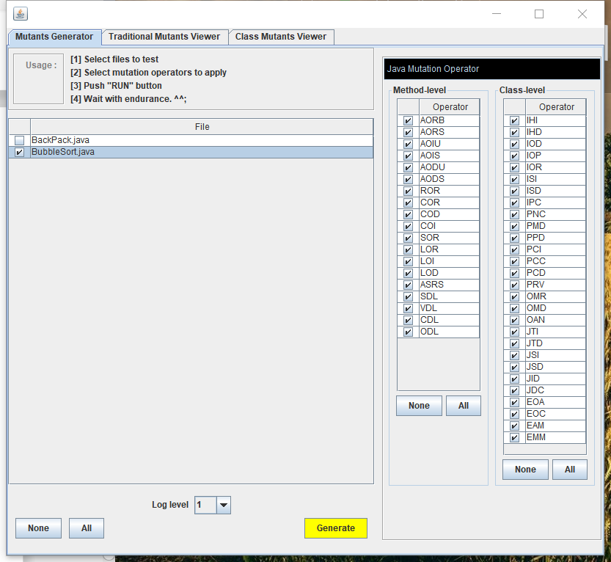

Mutants are generated:

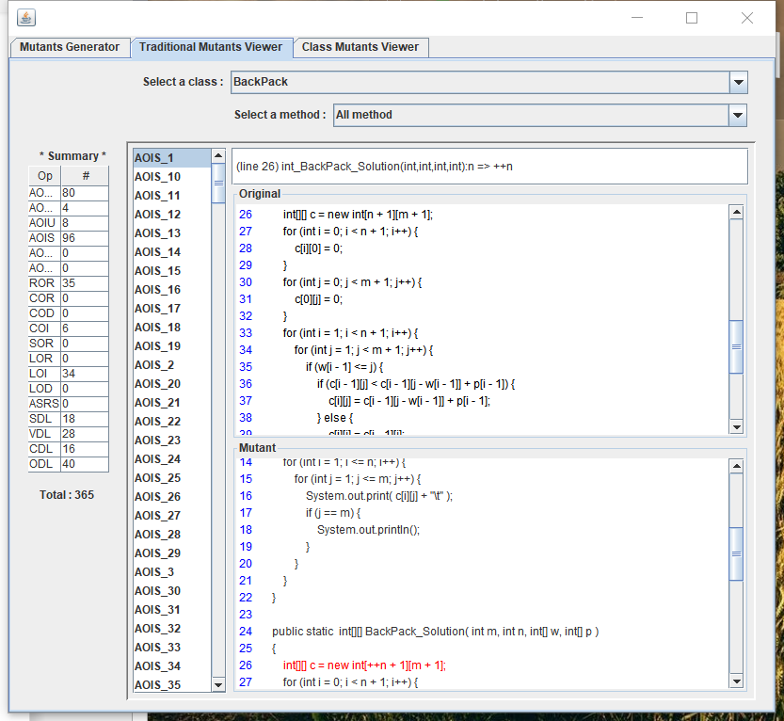

3. Making a test set

3.1 Make JUnit test case for these two file, compile, and move them to the directory MuJava_HOME\testset\.

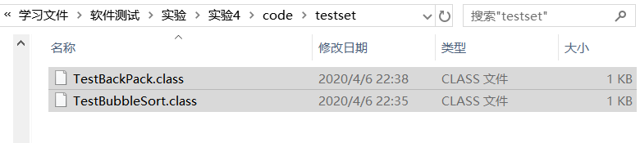

4. Run mutants.

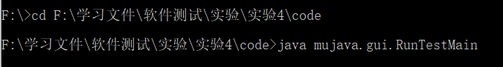

4.1 Run test case for BackPack:

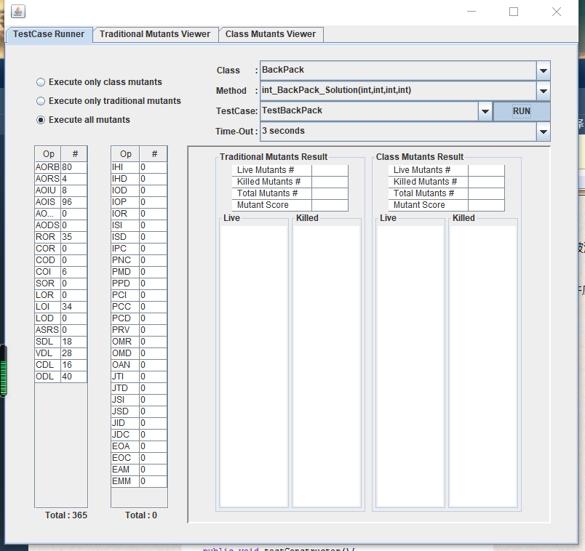

Results:

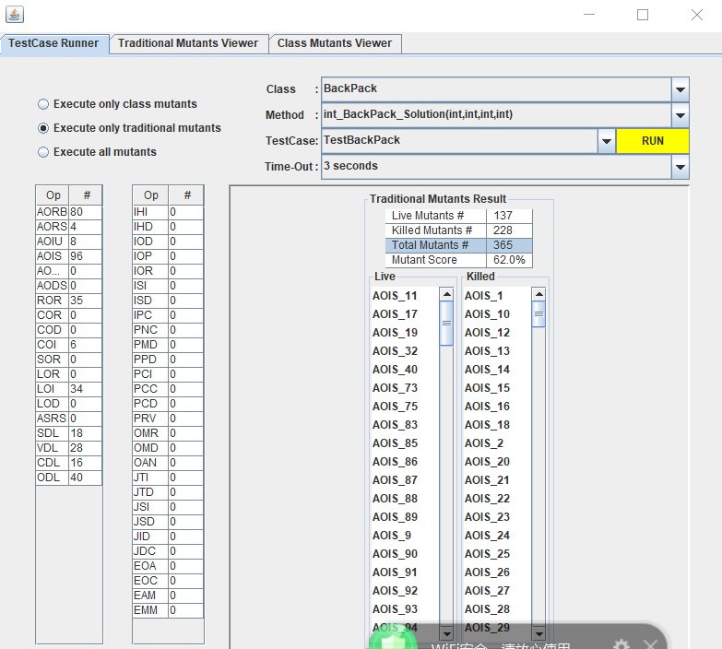

4.2 Run test case for BubbleSort:

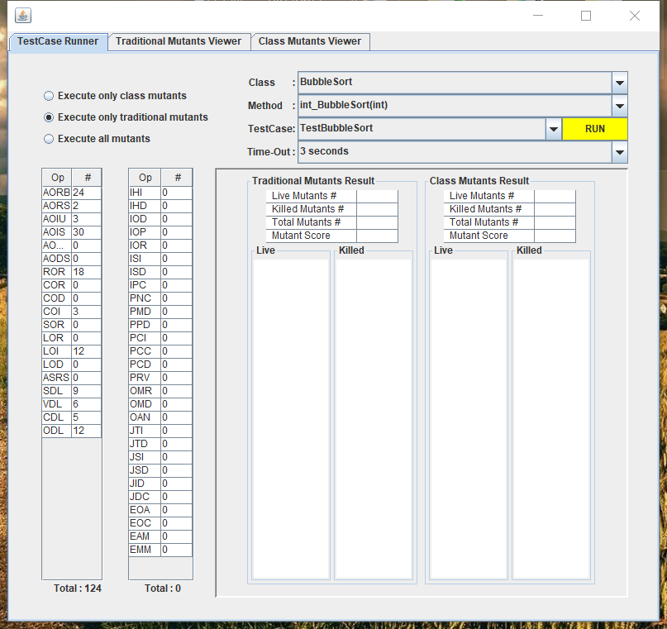

Results:

